

Names: Yasar Azimi

ID:# 44158

Participation 8

Dr.Abdalrahman Alfagi

Class: ITC 370

2023/12/8

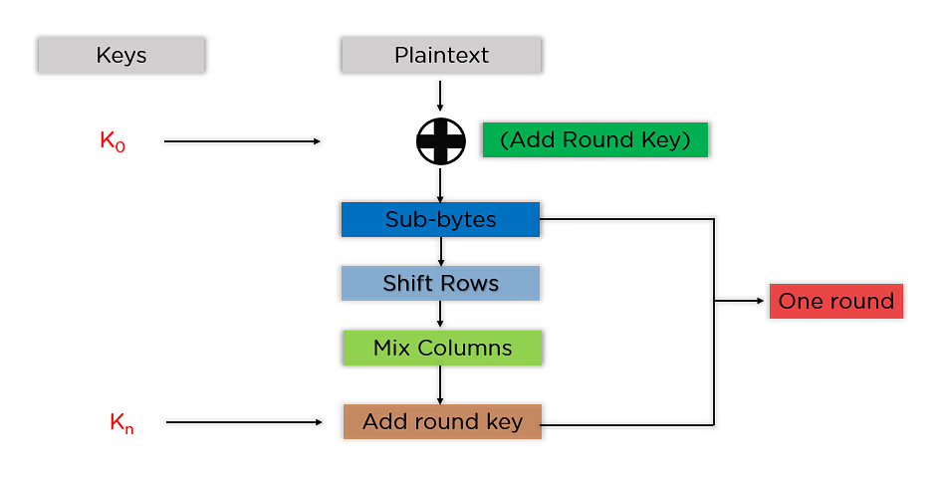We have explained the detailed structure of the DES. And based on the steps of encryption in DES.

**You have the following**

1. The plaintext in Hex. Format.

54 77 6F 20 4F 6E 65 20 43 69 6E 25 20 54 77 6F



1. The encryption Key in Hex. Format

54 68 61 74 73 20 6D 79 20 4B 75 6E 67 20 46 75

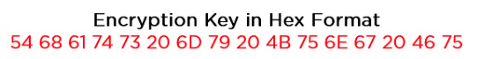

**Q1- Show the values of the input State before Add Rounf Key step? (1 point)**

**Answer: Plain text in matrix format**

|  |  |  |  |
| --- | --- | --- | --- |
| 54 | 4F | 43 | 20 |
| 77 | 6E | 69 | 54 |
| 6F | 65 | 6E | 77 |
| 20 | 20 | 25 | 6F |

**Q2- Show the values of the k0 that will be used for the first forward Add Round Key? (1 point)**

**Answer: Key in matrix format**

|  |  |  |  |
| --- | --- | --- | --- |
| 54 | 73 | 20 | 67 |
| 68 | 20 | 4B | 20 |
| 61 | 6D | 75 | 46 |
| 74 | 79 | 6E | 75 |